Priloga

»Priloga 13: Seznam območij z omejenimi možnostmi za kmetijsko dejavnost

Občina |  | Skupna površina (ha) | Ni_OMD (ha) | Gorsko (ha) | Naravne omejitve (ha) | Posebne omejitve (ha)
ID | IME
1 | Ajdovščina | 24.523 | 0 | 4.186 | 0 | 2.238
213 | Ankaran | 805 | 280 | 0 | 0 | 0
195 | Apače | 5.350 | 3.338 | 35 | 0 | 74
2 | Beltinci | 6.225 | 4.101 | 0 | 0 | 0
148 | Benedikt | 2.414 | 0 | 0 | 0 | 1.491
149 | Bistrica ob Sotli | 3.117 | 0 | 1.581 | 0 | 0
3 | Bled | 7.229 | 576 | 848 | 0 | 0
150 | Bloke | 7.507 | 0 | 2.978 | 0 | 0
4 | Bohinj | 33.373 | 0 | 3.340 | 0 | 0
5 | Borovnica | 4.232 | 0 | 429 | 762 | 0
6 | Bovec | 36.732 | 0 | 3.442 | 0 | 0
151 | Braslovče | 5.498 | 2.116 | 492 | 0 | 0
7 | Brda | 7.197 | 0 | 2.972 | 0 | 0
8 | Brezovica | 9.117 | 0 | 781 | 2.373 | 0
9 | Brežice | 26.806 | 7.018 | 5.756 | 0 | 0
152 | Cankova | 3.058 | 1.054 | 0 | 0 | 890
11 | Celje | 9.490 | 2.467 | 1.087 | 0 | 2
12 | Cerklje na Gorenjskem | 7.804 | 2.265 | 941 | 0 | 0
13 | Cerknica | 24.095 | 0 | 6.231 | 0 | 0
14 | Cerkno | 13.159 | 0 | 3.477 | 0 | 0
153 | Cerkvenjak | 2.453 | 0 | 0 | 0 | 1.415
196 | Cirkulane | 3.207 | 0 | 1.478 | 0 | 0
15 | Črenšovci | 3.369 | 1.851 | 0 | 0 | 0
16 | Črna na Koroškem | 15.596 | 0 | 1.397 | 0 | 0
17 | Črnomelj | 33.963 | 0 | 436 | 6.667 | 0
18 | Destrnik | 3.435 | 1 | 0 | 0 | 2.096
19 | Divača | 14.505 | 0 | 2.476 | 1.055 | 0
154 | Dobje | 1.749 | 0 | 1.007 | 0 | 0
20 | Dobrepolje | 10.315 | 0 | 1.902 | 0 | 0
155 | Dobrna | 3.166 | 0 | 1.059 | 0 | 0
21 | Dobrova - Polhov Gradec | 11.748 | 0 | 3.087 | 52 | 0
156 | Dobrovnik | 3.112 | 1.790 | 0 | 0 | 0
22 | Dol pri Ljubljani | 3.328 | 814 | 456 | 0 | 0
157 | Dolenjske Toplice | 11.021 | 114 | 809 | 0 | 247
23 | Domžale | 7.230 | 2.610 | 486 | 0 | 0
24 | Dornava | 2.840 | 690 | 0 | 0 | 1.078
25 | Dravograd | 10.500 | 0 | 3.113 | 0 | 0
26 | Duplek | 3.998 | 1.982 | 79 | 0 | 2
27 | Gorenja vas - Poljane | 15.325 | 0 | 4.219 | 0 | 0
28 | Gorišnica | 2.911 | 1.781 | 0 | 0 | 182
207 | Gorje | 11.622 | 0 | 1.051 | 0 | 0
29 | Gornja Radgona | 7.460 | 802 | 145 | 0 | 3.243
30 | Gornji Grad | 9.010 | 0 | 1.905 | 0 | 0
31 | Gornji Petrovci | 6.684 | 0 | 0 | 0 | 2.576
158 | Grad | 3.739 | 0 | 366 | 0 | 1.385
32 | Grosuplje | 13.379 | 0 | 1.112 | 3.369 | 0
159 | Hajdina | 2.182 | 1.456 | 0 | 0 | 0
160 | Hoče - Slivnica | 5.371 | 1.292 | 761 | 0 | 0
161 | Hodoš | 1.812 | 0 | 0 | 0 | 719
162 | Horjul | 3.255 | 0 | 1.174 | 0 | 0
34 | Hrastnik | 5.858 | 0 | 1.484 | 0 | 0
35 | Hrpelje - Kozina | 19.492 | 0 | 3.696 | 204 | 0
36 | Idrija | 29.369 | 0 | 5.070 | 0 | 0
37 | Ig | 9.878 | 0 | 849 | 2.644 | 0
38 | Ilirska Bistrica | 47.998 | 0 | 9.280 | 0 | 0
39 | Ivančna Gorica | 22.701 | 0 | 2.224 | 5.161 | 0
40 | Izola | 2.856 | 0 | 1.254 | 0 | 0
41 | Jesenice | 7.584 | 0 | 1.201 | 0 | 0
163 | Jezersko | 6.881 | 0 | 417 | 0 | 0
42 | Juršinci | 3.626 | 0 | 16 | 0 | 2.141
43 | Kamnik | 26.564 | 0 | 5.422 | 466 | 0
44 | Kanal | 14.653 | 0 | 1.853 | 0 | 0
45 | Kidričevo | 7.150 | 4.581 | 0 | 0 | 4
46 | Kobarid | 19.273 | 0 | 4.259 | 0 | 0
47 | Kobilje | 1.974 | 0 | 0 | 0 | 831
48 | Kočevje | 55.537 | 0 | 6.393 | 3 | 0
49 | Komen | 10.272 | 0 | 256 | 2.683 | 0
164 | Komenda | 2.406 | 1.132 | 0 | 0 | 0
50 | Koper | 30.332 | 1.664 | 7.506 | 0 | 0
197 | Kostanjevica na Krki | 5.831 | 618 | 879 | 0 | 73
165 | Kostel | 5.616 | 0 | 582 | 0 | 0
51 | Kozje | 8.969 | 0 | 3.416 | 0 | 0
52 | Kranj | 15.091 | 3.589 | 1.146 | 0 | 0
53 | Kranjska Gora | 25.631 | 0 | 1.891 | 0 | 0
166 | Križevci | 4.625 | 3.020 | 0 | 0 | 37
54 | Krško | 28.654 | 5.891 | 6.580 | 0 | 0
55 | Kungota | 4.899 | 1 | 2.546 | 0 | 0
56 | Kuzma | 2.285 | 0 | 392 | 0 | 525
57 | Laško | 19.746 | 0 | 6.359 | 0 | 0
58 | Lenart | 6.210 | 1.292 | 0 | 0 | 2.378
59 | Lendava | 12.102 | 6.746 | 0 | 0 | 0
60 | Litija | 22.138 | 0 | 5.309 | 0 | 0
61 | Ljubljana | 27.499 | 3.842 | 2.034 | 0 | 2.021
62 | Ljubno | 7.891 | 0 | 1.512 | 0 | 0
63 | Ljutomer | 10.723 | 3.562 | 810 | 0 | 2.175
64 | Logatec | 17.302 | 0 | 3.878 | 0 | 0
208 | Log - Dragomer | 1.107 | 0 | 0 | 473 | 0
65 | Loška dolina | 16.680 | 0 | 2.242 | 0 | 0
66 | Loški Potok | 13.446 | 0 | 1.898 | 0 | 0
167 | Lovrenc na Pohorju | 8.443 | 0 | 911 | 0 | 0
67 | Luče | 10.945 | 0 | 1.339 | 0 | 0
68 | Lukovica | 7.490 | 0 | 1.893 | 381 | 0
69 | Majšperk | 7.278 | 3 | 1.318 | 0 | 1.311
198 | Makole | 3.694 | 0 | 593 | 0 | 724
70 | Maribor | 14.747 | 1.450 | 3.276 | 0 | 0
168 | Markovci | 2.984 | 1.856 | 0 | 0 | 0
71 | Medvode | 7.759 | 1.250 | 730 | 0 | 0
72 | Mengeš | 2.246 | 957 | 39 | 0 | 0
73 | Metlika | 10.872 | 0 | 279 | 3.666 | 0
74 | Mežica | 2.645 | 0 | 598 | 0 | 0
169 | Miklavž na Dravskem polju | 1.254 | 663 | 0 | 0 | 0
75 | Miren - Kostanjevica | 6.278 | 354 | 27 | 0 | 952
212 | Mirna | 3.131 | 0 | 967 | 80 | 0
170 | Mirna Peč | 4.804 | 890 | 826 | 0 | 0
76 | Mislinja | 11.217 | 0 | 2.370 | 0 | 0
199 | Mokronog - Trebelno | 7.339 | 0 | 2.436 | 0 | 0
77 | Moravče | 6.138 | 0 | 1.950 | 447 | 0
78 | Moravske Toplice | 14.446 | 3.892 | 0 | 0 | 3.845
79 | Mozirje | 5.356 | 0 | 1.535 | 0 | 0
80 | Murska Sobota | 6.443 | 4.161 | 0 | 0 | 0
81 | Muta | 3.877 | 0 | 1.214 | 0 | 0
82 | Naklo | 2.829 | 846 | 9 | 0 | 0
83 | Nazarje | 4.340 | 0 | 903 | 0 | 0
84 | Nova Gorica | 27.949 | 212 | 4.576 | 0 | 1.159
85 | Novo mesto | 23.585 | 1.983 | 3.774 | 0 | 1.145
86 | Odranci | 693 | 523 | 0 | 0 | 0
171 | Oplotnica | 3.315 | 619 | 896 | 0 | 0
87 | Ormož | 14.159 | 2.332 | 701 | 0 | 5.432
88 | Osilnica | 3.622 | 0 | 259 | 0 | 0
89 | Pesnica | 7.584 | 2.232 | 2.787 | 0 | 0
90 | Piran | 4.345 | 14 | 1.621 | 0 | 0
91 | Pivka | 22.325 | 0 | 5.230 | 0 | 0
92 | Podčetrtek | 6.065 | 0 | 3.102 | 0 | 0
172 | Podlehnik | 4.602 | 0 | 1.496 | 0 | 1
93 | Podvelka | 10.388 | 0 | 1.505 | 0 | 0
200 | Poljčane | 3.750 | 0 | 402 | 0 | 766
173 | Polzela | 3.401 | 536 | 915 | 0 | 0
94 | Postojna | 26.987 | 0 | 6.851 | 0 | 0
174 | Prebold | 4.065 | 623 | 518 | 0 | 0
95 | Preddvor | 8.696 | 3 | 1.252 | 0 | 0
175 | Prevalje | 5.807 | 0 | 1.780 | 0 | 0
96 | Ptuj | 6.666 | 2.039 | 0 | 0 | 1.460
97 | Puconci | 10.766 | 2.582 | 0 | 0 | 3.277
98 | Rače - Fram | 5.124 | 1.885 | 862 | 0 | 0
99 | Radeče | 5.197 | 0 | 1.342 | 0 | 0
100 | Radenci | 3.412 | 939 | 0 | 0 | 1.021
101 | Radlje ob Dravi | 9.393 | 0 | 2.256 | 0 | 0
102 | Radovljica | 11.871 | 1.655 | 1.467 | 0 | 0
103 | Ravne na Koroškem | 6.345 | 0 | 1.737 | 0 | 0
176 | Razkrižje | 985 | 491 | 69 | 0 | 0
209 | Rečica ob Savinji | 3.008 | 0 | 977 | 0 | 0
201 | Renče - Vogrsko | 2.947 | 662 | 360 | 0 | 1
104 | Ribnica | 15.364 | 0 | 3.451 | 0 | 0
177 | Ribnica na Pohorju | 5.932 | 0 | 721 | 0 | 0
106 | Rogaška Slatina | 7.148 | 0 | 3.244 | 0 | 0
105 | Rogašovci | 4.015 | 0 | 0 | 0 | 2.485
107 | Rogatec | 3953 | 0 | 1.105 | 0 | 0
108 | Ruše | 6.081 | 0 | 620 | 0 | 0
178 | Selnica ob Dravi | 6.447 | 0 | 1.396 | 0 | 0
109 | Semič | 14.666 | 0 | 1.255 | 1.158 | 0
110 | Sevnica | 27.217 | 0 | 8.669 | 0 | 0
111 | Sežana | 21.740 | 0 | 744 | 5.113 | 0
112 | Slovenj Gradec | 17.369 | 0 | 5.080 | 0 | 0
113 | Slovenska Bistrica | 26.006 | 4.321 | 3.601 | 0 | 1.597
114 | Slovenske Konjice | 9.786 | 1.714 | 1.766 | 0 | 923
179 | Sodražica | 4.948 | 0 | 1.123 | 0 | 0
180 | Solčava | 10.275 | 0 | 676 | 0 | 0
202 | Središče ob Dravi | 3.279 | 1.357 | 0 | 0 | 402
115 | Starše | 3.397 | 1.952 | 0 | 0 | 0
203 | Straža | 2.853 | 937 | 35 | 0 | 0
181 | Sveta Ana | 3.716 | 0 | 38 | 0 | 2.133
204 | Sveta Trojica v Slov. goricah | 2.591 | 879 | 0 | 0 | 763
182 | Sveti Andraž v Slov. goricah | 1.760 | 1 | 0 | 0 | 1.190
116 | Sveti Jurij ob Ščavnici | 5.132 | 1.265 | 0 | 0 | 1.631
210 | Sveti Jurij v Slov. goricah | 3.071 | 1 | 137 | 0 | 1.860
205 | Sveti Tomaž | 3.809 | 0 | 0 | 0 | 2.235
33 | Šalovci | 5.816 | 0 | 0 | 0 | 2.687
183 | Šempeter - Vrtojba | 1.495 | 563 | 0 | 0 | 0
117 | Šenčur | 4.028 | 1.839 | 1 | 0 | 0
118 | Šentilj | 6.501 | 0 | 2.636 | 311 | 1
119 | Šentjernej | 9.596 | 3.023 | 901 | 0 | 459
120 | Šentjur | 22.225 | 1 | 7.537 | 0 | 2.350
211 | Šentrupert | 4.908 | 0 | 1.889 | 0 | 0
121 | Škocjan | 6.045 | 1.059 | 1.623 | 0 | 135
122 | Škofja Loka | 14.601 | 1.247 | 2.405 | 0 | 0
123 | Škofljica | 4.329 | 0 | 789 | 1.035 | 0
124 | Šmarje pri Jelšah | 10.765 | 0 | 5.628 | 0 | 1
206 | Šmarješke Toplice | 3.423 | 837 | 892 | 0 | 0
125 | Šmartno ob Paki | 1.815 | 247 | 509 | 0 | 0
194 | Šmartno pri Litiji | 9.489 | 0 | 2.445 | 0 | 0
126 | Šoštanj | 9.559 | 0 | 2.478 | 0 | 0
127 | Štore | 2.815 | 0 | 918 | 0 | 1
184 | Tabor | 3.469 | 435 | 633 | 0 | 0
10 | Tišina | 3.882 | 2.802 | 0 | 0 | 0
128 | Tolmin | 38.233 | 0 | 6.039 | 0 | 0
129 | Trbovlje | 5.816 | 0 | 1.270 | 0 | 0
130 | Trebnje | 16.332 | 0 | 1.096 | 5.058 | 0
185 | Trnovska vas | 2.289 | 1 | 0 | 0 | 1.537
186 | Trzin | 862 | 284 | 0 | 0 | 0
131 | Tržič | 15.537 | 0 | 2.239 | 154 | 0
132 | Turnišče | 2.384 | 1.710 | 0 | 0 | 0
133 | Velenje | 8.350 | 0 | 2.710 | 0 | 0
187 | Velika Polana | 1.867 | 814 | 0 | 0 | 0
134 | Velike Lašče | 10.318 | 0 | 2.417 | 0 | 0
188 | Veržej | 1.202 | 735 | 0 | 0 | 0
135 | Videm | 7.997 | 1.485 | 1.962 | 0 | 602
136 | Vipava | 10.741 | 0 | 1.549 | 0 | 1.375
137 | Vitanje | 5.938 | 0 | 1.672 | 0 | 0
138 | Vodice | 3.138 | 1.307 | 0 | 0 | 0
139 | Vojnik | 7.527 | 0 | 2.426 | 531 | 0
189 | Vransko | 5.334 | 178 | 1.251 | 0 | 0
140 | Vrhnika | 11.564 | 0 | 1.375 | 2.295 | 0
141 | Vuzenica | 5.010 | 0 | 1.087 | 0 | 0
142 | Zagorje ob Savi | 14.714 | 0 | 4.223 | 0 | 0
143 | Zavrč | 1.930 | 0 | 882 | 0 | 0
144 | Zreče | 6.704 | 0 | 1.915 | 67 | 0
190 | Žalec | 11.709 | 2.885 | 2.186 | 0 | 0
146 | Železniki | 16.379 | 0 | 2.395 | 0 | 0
191 | Žetale | 3.811 | 0 | 1.283 | 0 | 0
147 | Žiri | 4.922 | 0 | 1.489 | 0 | 0
192 | Žirovnica | 4.258 | 0 | 1.002 | 0 | 0
193 | Žužemberk | 16.434 | 0 | 0 | 3.685 | 0

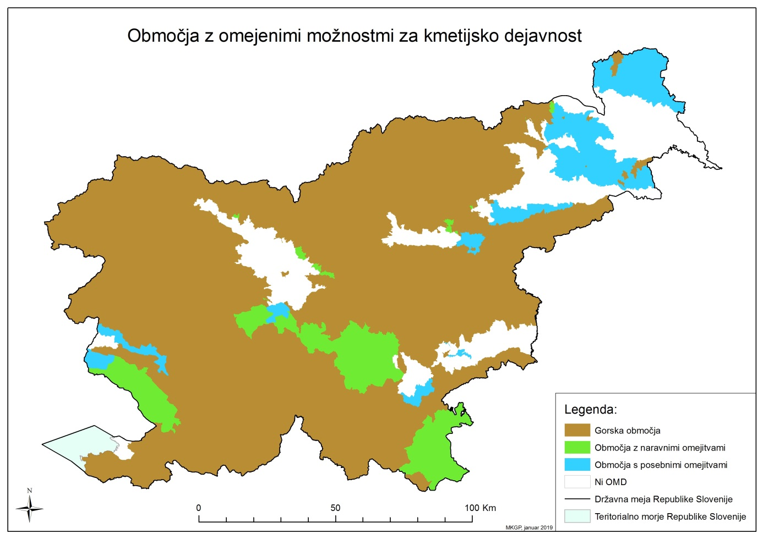
Karta 1: Območja z omejenimi možnostmi za kmetijsko dejavnost

«.

